|  |  |
| --- | --- |
| **Think Green** | Chris Kavanagh| C16492454  Submitted in partial fulfilment of requirements for the degree of BSc in Business Computing Technology University Dublin |
|  |  |

Table of Contents

Acknowledgements 4

Abstract 5

Introduction 6

The current Market 7

How Think Green can make a difference 8

Improving the environment through education 8

How a green workforce can benefit business 8

Future Opportunities in the Market 9

Project Objectives 10

Business Rules 11

Business Requirements 11

Actors 11

User 11

system 12

Use Cases 13

System 13

Main Application Pillars 14

News 15

Quizzes 15

Maps 16

Climate Change 16

CarbonFootprint 17

Recycle Menu 17

Database Design 18

ERD 18

Users 19

Carbon Footprint 19

Purchasing Value 19

Home Value 20

20

Food Value 20

Purchasing Value 20

Map Favorites 20

Materials 21

Material Favorites 21

Questions 21

Review Questions 21

Score 21

Sponsored Animals 22

News Favorites 22

System Architecture 23

Stack 23

User Requirements 24

Technologies Used 30

Tensor Flow 30

Adobe Creative cloud 31

Adobe XD 31

Adobe Photoshop 32

Illustrator 33

After effects 33

PayPal 34

Firebase 34

Firebase Storage 35

Android Studio 35

Java 35

GitHub 36

MP Android Chart 36

Python 36

Picasso 37

XML 37

API’s 38

News API 38

CoolClimate calculator API 38

Google Maps API 39

Directions API 39

My App Features 40

Quiz 40

What to do with your materials 42

Environmental News 45

Carbon footprint Calculator 47

50

Maps 51

Machine Learning Image Classifier 56

Climate Change 59

Animal Extinction 59

Earth’s Timeline 62

Test Plan 64

My Difficulties and what I have learned overall 71

References: 72

# Acknowledgements

I would like to give a special thanks to all of those who have helped me throughout my very long and tiresome final year journey filled with many ups and many downs. I could not have done it all without the continuous support from family, friends, classmates and lecturers.

First, I would like to thank my family who has been nothing short of amazing and kept me motivated throughout the hardest times. Without their continuous support and help not only through 4th year but throughout my entirety of college I don’t believe I would have achieved all that I have today.

Secondly , every lecturer has played their part in this project from 1st year right through to 4th I have learned many things in every module, all contributing to the development of my app. I want to thank Catherine Higgins for being very supportive and patient not only with me but with my whole course in the beginning when we all struggled with code; Catherine was always there to push us on and ensure we developed our skills further, I do believe without her motivating spirit and continuous support a lot of us wouldn’t be here today. Another special thanks to Jenny Munnelly and Thoa Pham, both who have played an integral part not only my Final Year project but in the contribution to the development of my coding skills. Jenny helped all my course advance leaps and bounds throughout the last two years with her challenging modules, Jenny has been beyond supportive for the whole course offering any help she can, constantly checking up to make sure everybody’s project is going okay. I can also say the same for Thoa Pham, she has been beyond supportive regarding everybody’s final year project, Thoa has been very responsive and helpful with any issues I raised with her throughout the year and without this continuous help, there is no way my project would have been developed to the standard it is today. Lastly, I would like to give Paddy Matthews a special thanks for being very supportive and most of all patient throughout my final year, Paddy has been unfortunately for him my go-to lecturer whenever I have any questions or queries. He has been very helpful with continuous advice and checkups to ensure I am going down the right path.

A special thanks must also be given to Alan Fahey who enrolled me in the STAR program of SAP. I learnt vast amounts during my two internships in SAP, all that have massively contributed to my problem-solving and business awareness skills. I utilized all of this in the development of my app. Alan has further helped offering me any support and guidance throughout the last two years.

Finally, I would like to thank my classmates who have provided me with some very great moments throughout the four years. I would like to thank two classmates in particular; Harry Thomas and Michael Gillen, together we spent countless early mornings and late nights in college and without their continuous support and humor, I believe there were several times I would have given up.

# Abstract

This project is a mobile application aimed for teenagers right through to middle ages adults. This application focuses on developing people’s knowledge on the environment and how to recycle correctly.

In this report I will demonstrate the systems main features and how these features were designed, and the technologies involved in making my application. I will discuss how I developed each feature and any problems I encountered throughout

# Introduction

The main aim of this project is to educate people on the environment and teach them how they can contribute to making our planet more sustainable. It has many features such as quizzes, a carbon footprint calculator, an image classifier and several other educational tools.

The main reason for this project is the fact that global warming is now an international concern. It is an app to help improve people’s knowledge on how they can play their part in saving the planet. With such a vast growing concern for environmental issues, and there being no place to upscale your knowledge on how to reduce your environmental impact, I felt it was an app that is needed.

Global climate change has already had an observable effect on the environment. Glaciers have shrunk, ice on rivers and lakes are breaking up, plant and animal ranges have shifted, and trees are flowering sooner. Effects that scientists had predicted in the past would result from global climate change are now occurring; loss of sea ice accelerated sea-level rise and longer, more intense heat waves. *(Nasa)*

The Intergovernmental Panel on Climate Change (IPCC), which includes more than 1,300 scientists from the United States and other countries, forecasts a temperature rise of 2.5 to 10 degrees Fahrenheit over the next century. (Nasa) Scientists have high confidence that global temperatures will continue to rise for decades to come, primarily due to greenhouse gases produced by human activities.

The effects of global warming are already here:

In Ireland alone, there has been increased growth in temperatures with record-high numbers in 2018 and then 2019. These increased temperatures are a direct effect from the global warming of the planet from environmental impacts. (MET.ie)

In 2018 Ireland had such high temperatures that a lot of the country faced a drought, the government placed limitations on water use. It prevented people from washing their car, watering their garden, and having long showers something you would never imagine could be effected by living unsustainably(MET.ie); unfortunately, the reality is; our actions do affect this. It is just the start; it will continually worsen unless we take a stance to change the way we live and become a more sustainable planet.

A study, compiled over three years by more than 450 scientists and diplomats highlighted that the biomass of wild mammals has fallen by 82%, natural ecosystems have lost about half their area, and a million species are at risk of extinction – all primarily as a result of human actions. (WWF)

# The current Market

In recent years the EU environment goods and services sector (EGSS) has grown quicker than the rest of the EU economy in value. During the years 2003 – 2015, EGSS value added increased by 63%. It further expanded by 2.5% in 2016, accounting for a total gross value added of 303 billion. In an economic perspective, it is evident that the market is a growing one. (EEA)

Greta Thunberg, a famous teenage activist, started the “Friday for future” protest in which millions of schoolchildren walk out of school every week in protest against global warming and the lack of action taken to stop it. These protests are one of the many ongoing issues that have contributed to 67% of people rating environmental problems as one of the nation’s most pressing issues. In the UK the public has ranked the environmental concern to be the third-highest matter higher than crime, economic issues and immigration; only health and Brexit was listed higher, this is just one example of many highlighting how important the issue has come for people. (guardian) But with all this concern, I was shocked to see the total lack of environmental apps there is on the current market**.**If anybody wants to boost their knowledge on the environment, they will be left to search blindly through the internet and read endless amounts of documentation and news articles; this is where my app “Think Green” steps in; My app brings all this to one place;

In my app users can boost their knowledge by reading relevant, up to date and organized news articles; in addition to this, they can further their knowledge with quizzes and other educational tools such as how to recycle certain items. There are very few apps that can track somebody’s carbon footprint and additionally give them the advice to improve it. Any carbon footprint calculators I have found are very technical and ask questions that are difficult to know the answer to such as; the exact number of calories of red meat a user eats every day. Additionally, my app focusses on boosting people’s knowledge of the environment; there are little or no environment educational apps on the market right now. This all presented to me a massive opportunity in which I wanted to take full advantage of.

# How Think Green can make a difference

## Improving the environment through education

A [2016 UNESCO report](http://unesdoc.unesco.org/images/0024/002457/245752e.pdf) named **Education for People and Planet – Creating Sustainable Futures for All** has stated that education can play a major role in bringing all changes and transformation that are required to make societies more environmentally sustainable. Governments, private sectors, and civil society can take initiatives in this matter.

Not only does environmental education help children to develop a sense of respect for nature, but it also teaches them how to think critically about the long-term consequences of their actions. This is a skill not only useful for those interested in conservation, but in every other aspect of life, too.

An analysis of the Global Warming Citizen Survey in the United States also showed that the higher a respondent’s education level, the greater his/her activism in terms of policy support, environmental political participation and environment-friendly behaviour.

By increasing awareness and concern, education can encourage people to reduce their impact on the environment through more efficient use of energy and water supplies, especially in areas of resource scarcity. In semi-arid areas of China, for example, educated farmers were more likely to use rainwater harvesting and supplementary irrigation technology to alleviate water shortages. *(World Education Blog)*

## How a green workforce can benefit business

Increasingly, businesses around the world are responding to a global imperative and [consumer demand](https://www.forbes.com/sites/natalieparletta/2019/04/22/consumers-are-choosing-brands-that-support-the-earth/#2654efffbf29) to go green. And more than 80% of people respect companies and brands that adopt eco-friendly practices, according to an [international survey](https://enginegroup.com/us/perspectives/articles/sustainability-is-the-market-making-easy-is-the-whitespace/). By making it easier for consumers, businesses can profit. Shoe company Adidas, for instance, united with Parley for Oceans to produce 7,000 [limited edition sneakers](https://www.forbes.com/sites/afdhelaziz/2018/10/29/the-power-of-purpose-how-adidas-will-make-1-billion-helping-solve-the-problem-of-ocean-plastic/#67ae11c0d215) made completely from plastic trash retrieved from the ocean. *(Forbes)*

Going green has [several other benefits](https://smallbusiness.chron.com/businesses-should-green-766.html) for companies. These include tax credits and incentives, improved efficiency, healthier workplaces, and cost savings – for instance by printing less, turning lights off in unused rooms and refilling ink cartridges. Reusing items also reduces waste from plastic packaging.

To examine this issue in detail, MIT conducted a one-year inquiry that involved in-depth interviews with fifty global leaders, followed by a survey of more than 1,500 executives and managers worldwide. The survey respondents cited the impact on a company's image and brand as its paramount reasons for addressing sustainability. Here are the drivers for addressing sustainability, listed in order of importance:

1.Company or brand image

2.Cost savings

3.Competitive advantage

4.Employee satisfaction, morale, or retention

5.Product, service, or market innovation *(Guardian)*

It is evident that going green has substantial befits to businesses, in generating profits and attracting the best most talented employees as more people become environmentally conscious. Think Green is an educational tool that can contribute to this transition.

# Future Opportunities in the Market

Throughout my time developing Think Green, I got in contact with many environmental companies to get advice on different situations as I wanted to ensure that everything that went into my app was researched and had a functional propose that contributed towards boosting people’s knowledge on the environment. I felt contacting business leaders in my app’s market was the right way to do this. Some situations where I looked for advice and just further clarity included; information on my carbon footprint calculator, the recycling situation in Ireland, the educational stance the Irish government has on the environment and how effective are the recycling labels placed on Irish products. I also got in contact with my old Secondary school principal and had a conversation about how environmental impacts have changed the educational outlook on global warming.

With great success, I had educational conversations with companies such as :

* repak.ie
* Mywatse.ie
* WWf
* An Taisce
* Cork Environmental Forum
* Unicef

Additionally, while talking with employees from these companies, they further told me what was missing from their current apps and websites; giving me advice and telling me how the current market of educational sources to learn about the environment isn’t up to high standards. Four companies further asked could they trial my app when finished as they believe it has the potential to be a very effective tool for educating customers and their employees. My Secondary school principal also asked could he use the app to help teach 1st – 3rd years the importance of recycling.

I felt this all highlighted a real need for an app like mine, an app that can teach people how to treat the environment; it further impacted my stance that there is a considerable gap in the market for this type of app.

# Project Objectives

My objective when developing this project was to create an application that deals with the lack of educational material there is regarding the environment. I wanted to integrate a creative and fun UI to ensure users are relaxed when using my application as it will provide maximum learning capabilities. There are very few apps like this on the market and it quite shocked me as climate change is a significant factor in our lives today.

User

* Register and Login to the application
* Add a profile picture to their profile
* View the latest and customized versions of environmental news
* Calculate their carbon footprint
  + View Tips to improve their footprint
  + View their footprints history
* Open customized google maps that highlight all recycling outlets
  + Have the capabilities to filter this map for a specific outcome
  + Search the map for specific locations
  + Get directions to each location to each location
* Be able to classify items they have using their camera
* Look through a menu of over 300 materials and see how each one can be recycled
  + Be able to search this menu for specific materials
* Enter the quiz menu and choose a quiz of choice
* Be able to use each quiz
  + Answer each question and receive more information regarding the answer
  + Answer the review quiz of questions they got wrong
* Enter the climate change menu and choose an option
* Scroll freely through the animal menu
  + Be able to view each animal individually

System

* Record who is online
* Send alerts to update their carbon footprint
* Classify materials
* Provide directions on the maps when requested
* Provide the latest and up to date news articles.

# Business Rules

* User’s must register to use the app for the first time
* User’s must be logged in to use the app
* Each user can only have one account associated to his/her email
* Each user must give permission for the app to use their location to use the maps function

# Business Requirements

## Actors

The actors in this application are the User and the System.

### User

Upon registering to the application, the user will be stored in the database; users must register with a name, email, username and password. Once registered the user can login with an email and password. Upon opening the app, the user will automatically be logged in as my authenticator has been built to remember the user unless they have manually logged out during their previous use.

Once the user is logged in, they will be brought to the main menu where they will see six menu buttons.

**News:**The user can view the latest environmental news, or they can choose to customize it by selecting their desired news outlet such as RTE or the Irish times.

**Footprint calculator:**The user will be capable of obtaining their carbon footprint by answering a series of questions, they will then be provided with results and be given the option to view tips on how to improve. Each footprint will be recorded, inputted to the database and displayed on a line chart to show the user their history of footprints.

**Maps:**If the user has not used this function before, they will be asked to give the app permission to use their location. Once this permission has been given, the user can filter the map by choice. They will then be presented with a map of all recycling outlets in the location of their choice. They should be able to filter the map in a sidebar menu and search for specific locations.

**Quiz:**The user should be able to choose the quiz of their choice from the menu. After choosing a quiz, they should be able to complete each quiz fully. After answering each question, the user should be presented with additional information based on the answer to further educate them. The user should be presented with a results screen showing them how much questions they got incorrect and correct.

**Recycling menu**:

The user should be able to choose each recycling option. When the machine learning is chosen, the user will have to grant the app access to their camera they then will have the capabilities to classify their item and be presented with a result on an additional screen. If the system classifies the item is glass or metal, they will be presented with the option to view the closest recycling outlets that allow them to recycle that material.

If the user chooses the ‘what to do with your materials’ option, they will be given a list of items they should be able to search for specific items or select items from the list. When selected, they will be presented a screen of information on the selected item.

**Climate Change:**The user should be able to choose either option, earth’s timeline or animal extinction. When the Earths timeline is chosen, the user will be presented with a screen with a timeline bar and the current globe rotating and a description of the globe. When the user chooses 2120, the globe will change to a burning globe rotating and a description of why the globe is burning. If the user chooses animal extinction from the menu, it will present a list of animals; the user should be able to select an animal to see how they are going extinct.

### Sytem

The system is required to track who is logged in; it is further required to track each time somebody has completed a carbon footprint calculation and provide them with results.

The system should be capable of sending alerts to the user if they have not completed a footprint calculation in a while.

The system should have the capabilities of providing the latest up to date news on the environment.

The system should be able to classify what material the user is highlighting on their camera.

It will have the capabilities to provide the user directions on google maps when requested.

# Use Cases

## Main Application Pillars

## News

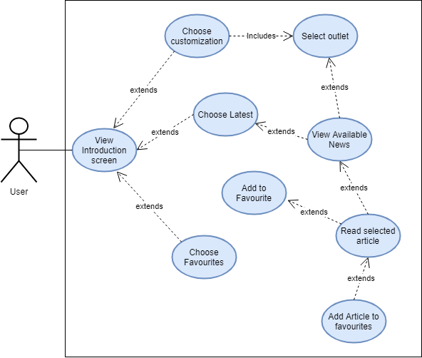

## Quizzes

## Maps

## Climate Change

## A close up of a map Description automatically generatedCarbonFootprint

## Recycle Menu

# Database Design

## ERD

## Users

The user table holds all details about the user including a uniqueID which is generated through the Firebase Authenticator pattern when a user registers.

The users name, username and email are all entered when the user first registers, the email is required to sign in.

The image URL is set as default when the user first registers, it can be customized through the users ‘My profile’ section. The score is set as 0 when a user first registers, it then will be updated on a continual basis when they contribute to their score.

## Carbon Footprint

The Carbonfootprint table holds the carbon footprints of all users. This table is created when a user calculates their footprint. The table holds a unique id of footprintID to keep each footprint calculation unique. Footprints will be separated through the UserID. Each footprint will have a value and a timestamp so the user can track when they calculated their footprint last.

## Purchasing Value

Purchasing value holds the purchasing value of each footprint and the timestamp. The footprintID keeps value unique.

This table allows me to carry out analysis on a User’s history based on the specific purchasing section.

## Home Value

Home value holds the home value of each footprint and the timestamp. The footprintID keeps value unique.

This table allows me to carry out analysis on a User’s history based on the specific home section.

## Food Value

Food value holds the food value of each footprint and the timestamp. The footprintID keeps value unique.

This table allows me to carry out analysis on a User’s history based on the specific food section.

## Purchasing Value

Travel value holds the travel value of each footprint and the timestamp. The footprintID keeps value unique.

This table allows me to carry out analysis on a User’s history based on the specific travel section.

## Map Favorites

The Map favourites table holds all the locations saved by the user. It gives the User easier and quicker access to their favourite locations.

Each location has a uniqueID as “MarkerID”. LatLng represents the locations coordinates, Name hols the location name for eg: Carpark, Shopping Centre, Garden Centre etc.

Category holds the locations recycle station value i.e.. Bring bank. Address holds the locations address and city holds the city this location is in

## Materials

The Materials table holds all the values of the recyclable items. Each material is identified by their name, no material can have the same name. Each material will have a generalcomment , how, what , where and why value. Each of these values represent advice for the user and what to do with that chosen material if they want to recycle it

## Material Favorites

The Materials favorite table holds all the materials saved by the User. User ID is the unique id as it distinguishes the difference In users. The MaterialName is then saved to reference the material in the Materials table.

## Questions

The Questions table saves all questions in the App. Each question has a unique identifier as ‘QuestionID’. Each question is organised by the category value. There are various different categories. Each question will have four answers, one question, one description and one score value.

## Review Questions

The ReviewQuestions table holds all the questions a user has got wrong. The User Id will have a number of question Id’s that relate back to the Questions table

## Score

The score table holds all scores achieved by the users. The scores are categorised by the User ID. This allows me to search through the table finding only scores associated with a specific user. Each score has an associated time stamp for when this score was achieved .

## Sponsored Animals

If a user ever chooses to adopt or sponsor an animal through the app, this animal will be added to the Sponsored animals table. Giving the user the opportunity to see which animals they have sponsored. Package refers to which package the user chose to sponsor the animal with. There are different values, Gold, Silver and Bronze.

## News Favorites

New favourites refer to all articles saved the User. If the user sees an article they like and want to save this, they just click save. Once saved this table is created saving the article and all its details, allowing the user to revisit the article whenever they please

# System Architecture

TensorFlow

Adobe Creative cloud

CoolClimate API

News API

Paypal

Maps API

Python

XML

Java

Android

Firebase

# Stack

Firebase

Android

# User Requirements

|  |  |  |
| --- | --- | --- |
| Function | Requirement | Justification |
| Register | Ability to create an account with an associated email and password | To use the applications functionalities a user must be logged in and to be logged in a user must first create an account |
| Login/ Log out | Users of the app must be able to log in and out of their accounts | The applications functionalities won’t be available unless a user logs in. A user should also be able to log out of their account. |
| Enter News Section | The user should be able to enter the news section of the app | The User must have these capabilities in order to view the news. |
| Enter the Footprint calculator section | The user should be able to enter the footprint calculator section | For the user to check their footprint they must be able to enter the footprint calculator section |
| Enter the Google Maps section | The user should be able to enter the Google maps section | If the user wants to check where their local recycle stations are they have to enter the Google maps section |
| Enter the Quiz section | The user should be capable of entering the quiz menu section | The user must be in the quiz menu section to engage in any of our quizzes |
| Enter the recycle menu section | The user must have the capabilities to enter the recycle menu section. | For the user to use any of the recycle tools they must be capable of entering the recycle menu section |
| Enter the Climate Change Section | The user must have the capabilities to enter the recycle menu section. | If the user is to engage in any of the climate change sections, they must be able to enter the climate change menu. |
| Choose whether they want to customize their news or not | The user must be capable of choosing between whether they want to see latest or customized new | The user must be able to see customized news as there are several news companies’ users might not trust |
| **Function** | **Requirement** | **Justification** |
| Choose which news outlet they would like to see | The user must be able to choose which news outlet they want to see from the list of available outlets | The user must be able to see their desired outlet chosen. It allows them to choose the outlet they are most comfortable with |
| The user must be able to see the latest news | If chosen, the user must be able to see the latest news headlines regardless of the outlet | If the user is more interested in the latest articles regardless of the news outlet, they should be allowed to see the latest articles |
| Read any article they want to | The user must be able to view the article in full if they choose to . | The user must be able to choose the article and read it in full as it makes no sense to be able |
| Answer all questions presented to them | The user must be capable of answering all the questions presented to them. | The user must be able to answer all the questions in order to get an accurate carbon footprint reading |
| View the results sheet from their footprint | The user must be able to view the results sheet showing a pie chart of their results | The user must be able to see the results they have gotten for their carbon footprint calculation |
| Choose a specific category for advice | The user must have the capabilities to choose the category of their choosing | They may be more interested in specific categories based on their results. |
| See all three tips in the food section | The user must be able to see all three tips in their food section | The user must be able to see all three tips available to them to really fulfill the advise section |
| See all three tips in the travel section | The user must be able to see all three tips in their travel section | The user must be able to see all three tips available to them to really fulfill the advice section |
| See all three tips in the home section | The user must be able to see all three tips in their | The user must be able to see all three tips available to them to really fulfill the advice section |
| **Function** | **Requirement** | **Justification** |
| See all three tips in the purchasing section | The user must be able to see all three tips in their purchasing section | The user must be able to see all three tips available to them to really fulfill the advice section |
| See their history for footprint calculations | The user must be able to view their previous footprints | To see their progress and improvements we must show the user their previous results |
| Follow the map instructions | The user must be able to follow the map instructions, so they know how to use the maps | If the user wants to use the maps correctly |
| Filter the map at the introduction stage | At the introduction stage the user must be able to filter the map the way they like | They need to filter the map in order to see markers on the map |
| Zoom in and out, scroll through the map | The user must be able to use the map as normal by zooming in and out and scrolling through it | It allows the user to see the different recycle stations at different levels. |
| View the side bar | The user must be able to see the side bar by clicking the search button in the top left corner | The user must be on the side menu to filter the maps, view specific locations etc |
| Filter the map | The user must be able to filter the map while in google maps | It allows the user to filter the map in realtime rather than going through the menu process again |
| Search the recycler view | The user must be able to search the recyclerview for a specific location | If the user wants to find a specific location, they must be able to search for this rather than scrolling aimlessly |
| Click on a specific location | The user must be able to click on a specific location and be brought to this location | If the user wants to see somewhere specific this allows them to do s. Stops users searching aimlessly through the map |
| **Function** | **Requirement** | **Justification** |
| Must be able to return to the map screen | The user must be able to return to the maps screen by clicking the maps button | It allows the user to return to the maps to see the recycle stations |
| Return to the main menu from maps | The user must be able to return to the home screen from the maps function | It allows the user to leave the maps function when they are finished using it. |
| Choose which quiz they would like to do | The user must be able to click into specific quizzes based on which one they want to do | This allows the user to enter each quiz they want to. They must be able to do this in order to take part in the quizzes |
| Choose which level they would like to take part in | The user must be capable of choosing which level they want to take part in | It allows the user to answer questions of all difficulty from level 1 to level 3 |
| Answer each question in the quiz | The user must be able to answer all the questions in the quiz. | To take part and get results the user must be able to answer all questions |
| View the answers of each question | The user must be provided with the answer to each question | By providing the user with the answer to each question we help the learn and boost their knowledge further. |
| Be provided with results from the quiz | The user must be provided with the results from their quiz | It allows them to see their results they will be told how many questions have been added to their review questions |
| Choose one of the three options on the recycle menu | The user must be able to choose between the menu items in the recycle menu | The user can’t use any of the recycle functions unless they can choose from the menu |
| **Function** | **Requirement** | **Justification** |
| Scroll through the recycle options | The user must be able to scroll through the list of materials | The user has to scroll through the items to see all options available |
| Search for materials through the search bar | The user must be able to search for specific items through the find an item search bar | This allows the user to find items they are looking for rather than scrolling through a list filed with hundreds of items |
| Select one of the four items at the top | The user must be able to select one of the four items at the top of the screen | The four items are the most commonly mis recycled items and they must open when the user recycles to show how to recycle them |
| Choose any item from the list | The user must be able to choose any item from the list | The user must be able to choose any item from the list in order to see how they can recycle it. |
| See all advice on how to recycle that item | The user must be able to see all the advice when they click on a specific item | After the user chooses an item, they must be able to see the advice to recycle the item |
| Follow the instructions on the classifier | The user must be able to follow the instructions on the classifier | For the user to understand how to use the classifier they must understand how to use it |
| Open their camera in the classification section | The user must be able to open their camera in the classification section | The user has to open their camera to use the classifier |
| Classify an item | The user must be able to classify which item is in their camera | For this function to work the classifier must be able to distinguish which item is which |
| See results | The user must be able to see the results of their classification | For the user to learn about their item they must be able to see results and advice on their item |
| **Function** | **Requirement** | **Justification** |
| Enter maps from the classification section | The user must be able to enter the maps section from the classification results page | When a user gets a glass or metal, they will be shown the closest place to recycle this material. |
| Choose a menu item from the climate change menu | The user must be able to choose between the two menu options | To use the functionality of the climate change menu options they must be able to choose which ones to use |
| Read and proceed from the initial animal introduction screen | The user must be able to read and then proceed from the initial animal extinction screen | The screen gives background information on animal extinction due to climate change |
| Select a specific animal from the recycler view list | The user must be able to choose which animal they would like to see | In order to see the information on each animal the user must be able to choose one from the recycler view |
| See information on the animal | The user must be able to see must be presented with the animal details when clicked | The animal information is the main function the user must be able to see this if they choose to |
| Read and proceed from the initial planet introduction screen | The user must be presented with an initial introduction page on climate change effects on the planet | The initial introduction screen gives the user background information on the planet and climate change |
| View their own profile | The user must be able to view their profile | The user must be able to view their profile for them to edit details |
| Edit personal details | The user must be able to edit their personal details | The user must be able to edit their personal details |
| Change their profile photo | The user should be able to change their profile photo | To add personalization the user can change a profile photo of themselves |

# Technologies Used

## Tensor Flow



I wanted to build an image classifier so people could look at items in their everyday life and see if it is recyclable. I did a lot of research and felt that tensor flow offered me the best opportunity for me to do this. I then used TensorFlow and chose a built image classifier model and built it to suit my needs. My Image classifier uses 5 labels’

* Paper
* Plastic
* Trash
* Glass
* Metal

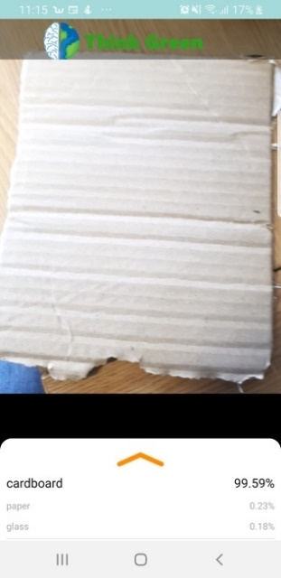

## Adobe Creative cloud

I used the Adobe creative cloud to help create a very customized and original user interface. I used a combination of Adobe XD and Photoshop to create background images, graphics and icons.

I used Illustrator to create my logo and graphics for my gif’s and icons. I used After effects to create the Gif used to portray what the earth may look like in 2100.

I taught myself how to use this creative suite and functions through many hours of online courses from LinkedIn Learning.

### Adobe XD

I felt there was a need to develop my user interface further beyond the simplistic approach taking in android studio. I began to teach myself how to use Adobe XD to build my user interface at such as menu, login & register pages. After some research into the humans, capabilities to learn more when in a relaxed state I further made the use of Adobe XD to develop my whole user interface with maximising user relaxation and user ease at the core of my development. I also wanted to use to go further than using XML and Android studio UI as I wanted to make my app different from others and I believe the use of Adobe XD does this. I created 62 Android screens that are completely original and solely developed by myself; it brings a sense of originality to my app while also enhancing the user experience massively. Everything was created with the end-user in mind; I continuously asked myself does this benefit my project and does it help the user understand what is on the screen.

Some Examples:

### Adobe Photoshop



Adobe photoshop was used to create graphics, these graphics were then used in adobe XD to form my user interface. I used a lot of graphics rather than simple buttons as I felt it was a better approach. I also used a lot of graphics to help represent the point I was making such as in my advice screens

### Illustrator



I used illustrator to design my logo, I also used it to build customized maps that I then used in building gifs to represent what the earth would look like in 100 years. Illustrator was also used to develop those more complex graphics with more detail. These graphics were then also used in the development of my UI.

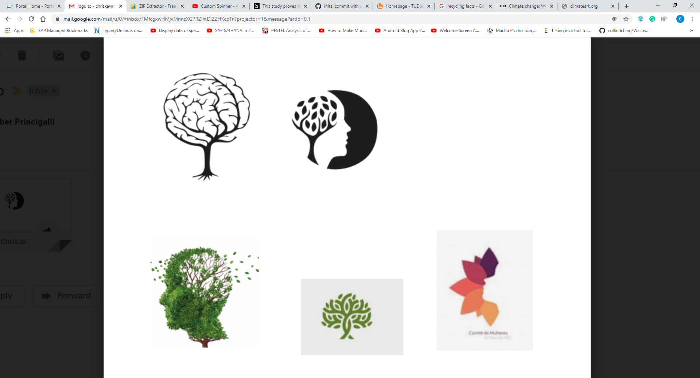

### After effects



Adobe After Effects is a digital visual effects and motion graphics suite. I used it to create gifs to represent the earth in a more realistic manner. It was used to show people what the planet could look like in 100 years if climate change continues to worsen. I felt I needed a realistic representation to get my point across of how serious the situation is

## PayPal



I used the PayPal SDK to develop a paypal checkout option allowing users to make purchases through my app. I used the PayPal Checkout UI. This give the use a very simplified , secure and easy checkout experience.

.

## Firebase

I chose to use firebase as my database as it is a Realtime database, and in the cloud, it suited my app. I felt a firebase database in combination with an android app complement each other and help make the app run very smoothly. I further used Firebase storage; this is used to store all pictures.

## Firebase Storage



I use firebase Storage to store any photos added by the user, each time the user wants to change their photo this uploaded to storage and a link is saved in the Firebase Realtime Database.

## Android Studio



I chose to develop an app over a web app solely because of the continued use of phones in all age groups. The use of smartphones is becoming more prominent in life, and it presents me with an opportunity and a market that is undoubtedly growing. As well as this, my project idea had little or alternatives for mobile applications, so I felt this again presented me with an opportunity.

## Java

Java is the first program language I learned in college in first year, so it was a choice I was most comfortable with. I felt like I could add more complexity to my app through java and not through other languages as I didn’t have the capabilities to do so.

## GitHub



GitHub was used as my version control system to keep my project up to date in the cloud. It provides access control and several collaboration features such as bug tracking, feature requests, task management and wikis for every project.

## MP Android Chart



A powerful Android chart view/graph view library, supporting line- bar- pie- radar- bubble- and candlestick charts as well as scaling, dragging and animations. The MP AndroidChart Library helped me get my point across with emphasising people’s carbon footprint impact through visualisation using pie charts and Line charts

## Python



I used python code in the development of my Tensorflow image classifier model. Python was the recommended language to use as it integrates best with TensorFlow’s c++ back end additionally NumpPhy also makes it easier for pre processing in Python.

## Picasso

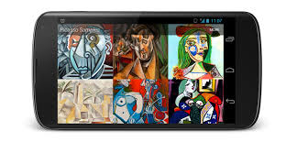

My application uses a lot imagery to be visually stimulating. Picasso is a powerful image downloading and caching library, this helped me massively in retrieving images such as for my News API and loading images into my database with the user profile. Picasso helps with the resizing and fitting of images with less memory consumption

## XML



XML is used in the android layout files. I used xml in my application in combination with Adobe for the UI.

The Layout files were used to arrange the activity layout, facilitate buttons and views developed in AdobeXD. XML provided a very easy method to facilitate my use of the adobe creative cloud.

# API’s

## News API



News API is an HTTP REST API for searching and retrieving live articles from all over the web. It can help me produce knowledgeable articles that answer questions such as:

* What are the top environmental stories in the NY Times?
* What new articles were published about the climate crisis?
* Are there any scientific updates on how to save the planet?

The news API allows me to have all environmental articles organized into one area; it removes the need for people to search through the internet looking for relevant articles trying to boost their knowledge on the environment. It also provides people with the opportunity to keep up to date with relevant environment movements.

## CoolClimate calculator API

The cool climate calculator allows individuals to calculate their carbon footprint. I used this API as it allows me to choose which questions I ask, and I can customize the API to suit the needs of my app. It allows me to ask simple questions and not very technical and complicated questions like other apps. With this, I can get a set of results and then offer individuals personalized advice on how to improve their footprint and further help reduce their impact on the environment.

It was more complicated than I had first anticipated. I originally had anticipated a straightforward plugin and play API, although I quickly realized this was not the case. I had to do a lot of research to find the values that would be inserted for each user. For example, I had to check the average speed of trains in Ireland to find out how far each user would travel if they were on a train for 4 hours a week, other research I had to do was the average miles per gallon on medium-sized cars, and the average amount of calories ate per user based on their diet. Although it was a lot more work, it makes my carbon footprint calculator more accurate and more suitable to my app rather than asking the technical question such as how much km you travel each week by train, as most users will respond with an uneducated guess or will be frustrated by the very complicated question.

## Google Maps API



I used the google maps API as it is the most commonly known maps to everyone in the world. It also offers a very simplified approach to set up and getting to work in my app. Further the google maps API offered me the most freedom to add additional code and customizations to suit my apps functions.

## Directions API



Directions API is an add on to the google maps API. I chose to use this as it has allowed me to create routes from the user’s location to their chosen recycling outlet. It offered me simplicity and allowed me to add in algorithms when needed.

# My App Features

## Quiz

It was essential for me to keep in mind that the objective of my app is to boost people’s knowledge and awareness of the environment when choosing my questions. It is easy to ask environmental questions that did not have any relevance or were not beneficial to the everyday user. Although it would not contribute towards my goal of educating the user; so I had to ask myself does this question affect the everyday life of a user.

With this, I had continually referred to my first point, creating awareness and boosting knowledge. I wanted to do more than ask the user a question when answered a user will be prompted with an additional screen telling them if they are correct or incorrect followed by a detailed description on the issue teaching the user about the environment and the impact it has.

I created the quiz interface with Adobe XD. I wanted it to have a very sleek feel, so users wouldn’t become frustrated, I needed users to be relaxed to maximize their learning capabilities. Users have the potential to take in 100% more information when they are relaxed vs being stressed. *(unicaf).*

In my app, I have multiple quizzes differentiated by topics; some of these topics include plastic, pollution, energy and the ocean. I also added quizzes to see if you understood which materials were recyclable; When answered, I offered insight into the materials, why they were or were not recyclable.

Each time the user finishes the quiz they will be presented with a results scree, informing them of their result and what % they got. If the user gets any questions wrong these will be added to the review quiz. A review quiz is filled with all the questions they user has got wrong, I do this as it is important to implement repetition as it boosts learning.

## What to do with your materials

This section of the app was here to improve the everyday life of users; from a personal stance, there are many times I have household items that I want to get rid of and have no idea how to recycle them or where to bring them. This feature answers all these questions with hundreds of items you will never be left confused again. This feature really does help the user while also boosting their knowledge and awareness of how important it is to recycle correctly

The user can scroll through the list at ease, or if they are looking for something in particular, they can search using the search bar at the top.

I added four items at the top Aerosols, Medicine, Batteries and pizza box; these are shortcut items; I specifically chose these items as they are the most commonly to be recycled incorrectly.

To make it easier on the user they can add any product they like to a favourites list. This will save the material for them and give them the option to see just that list by clicking the favourites button. This reduces the user stress by removing hundreds of items from the list and showing only the items they want to see.

Most materials had different values which caused some complications; for example, Aluminum trays only had a name what where and why.

While Dishwasher has name, what, where and general comment, so, when you click on the material to view its contents there would be an error as it might search for general comment. However, the material does not have a general comment value. I had to overcome this by creating an algorithm that would find the item in my database, then check for its values and then it would display a content view unique to those values.

This allowed me to display materials and their values correctly without having to settle for displaying materials with missing values.

Developing this feature provided a lot more complications than I had anticipated, I wanted to use a basic online web scraper that would scrape these items but with there being two screens the material list and the material descriptions. When trying to scrape the value using code, it was also tricky as they had different tag names so I could not just scrape by tag name.

I ended up scraping by searching for words with <h2> tag, meaning I would find the titles and then got the information text following this. I scraped this into a JSON file and then parsed this into my app. Although as stated above some features had different values, e.g., some features had values of name, what, where and how. So, I had to create a material object which had values of all possible results: name, What, Where, Why, how and general comment. Knowing if I tried to add a material with no general comment value to my database, I would get an error I had to create an if statement algorithm to set an item’s value as " “ if it did not contain the specified value required

if (jo_inside.has("Where?")) {  
 Where = jo_inside.getString("Where?");  
  
 } else {  
 Where = " ";  
 }  
 if (jo_inside.has("Why?")) {  
 why = jo_inside.getString("Why?");  
  
 } else {  
  
 why = " ";  
 }

Name = material.getName();  
 what = material.getWhat();  
 where = material.getWhere();  
 how = material.getGeneralComment();  
 why = material.getWhy();  
 generalcomment = material.getGeneralComment();  
  
 title.setText(Name);  
 What.setText(what);  
 Where.setText(where);  
 tip.setText(generalcomment);  
  
  
 if(how.equals(" ") & why.equals(" ")){  
  
 setContentView(R.layout.*activity_materialview*);  
  
 }  
 else if(generalcomment.equals(" ") & how.equals(" ")){  
  
 setContentView(R.layout.*materialviewwhy*);  
 What = (TextView) findViewById(R.id.*what*);  
 Where = (TextView) findViewById(R.id.*Where*);  
 title = (TextView) findViewById(R.id.*Title*);  
 Why = findViewById(R.id.*Why*);  
  
 Why.setText(why);  
 title.setText(Name);  
 What.setText(what);  
 Where.setText(where);

## Environmental News

The News API is here to boost people’s knowledge on the environment; it enables easy access to relevant documents and articles, removing the need to search through hundreds of articles each time on the internet. I parse this these articles into my app through a customized url based on what the user chooses. These articles are then added to a recyclerview for the user to see. The user can then choose to read the article by clicking on it.

FEED_URL = "https://newsapi.org/v2/everything?q=climate change&sources=" + domain + "&apiKey=e31fb6b25b2d4051ac0b1b62f49d2d69";

new ArticlesActivity.AsyncHttpTask().execute(FEED_URL);

try {  
 JSONObject response = new JSONObject(result);  
 JSONArray posts = response.optJSONArray("articles");  
 ArticlesItem item;  
 for (int i = 0; i < posts.length(); i++) {  
 JSONObject post = posts.optJSONObject(i);  
  
 title = post.optString("title");  
 image = post.optString("urlToImage");  
 description = post.optString("description");  
 Company = post.optString("name");  
 date = post.optString("publishedAt");  
 url = post.optString("url");

Each user can also save articles by choosing to “add to favourites”. This helps the user keep track of any interesting articles they have read and what to save for later. The user will click the add to favourite button, this will get the article and add the details of this article to the database.

ArticlesItem favitem;  
favitem = new ArticlesItem();  
favitem.setTitle(item.getTitle());  
favitem.setImage(item.getImage());  
favitem.setUrl(item.getUrl());  
favitem.setDescription(item.getDescription());  
favitem.setDate(item.getDate());  
favitem.setName(item.getName());  
  
reference.push().setValue(favitem);

I have added in additional features that allow a user to choose which news company they wish to see news from, how up to date their news is and if it is sorted by most popular or latest posted.

I do this as some people can have precautions to which news site they trust, of people, do have these precautions they can choose to look at news from a website they trust and learn in comfort. If people want to see the latest environmental news, they can do that no problem.

## Carbon footprint Calculator

As stated above, I wanted to add a carbon footprint calculator into my app as there are no calculators online or apps that have calculators that simplify the process for you. Many questions look for extremely detailed answers an example is; the exact amount of calories you consumed in a week that consisted of red meat; this not something everyone would know and can be quite frustrating. Other technical questions I have seen is the number of km travelled by train or the exact money spent on electricity again for people living at home and are not paying these bills such as teenagers, they more than likely won’t know this answer. In the below example I show some of the if statements I use to find the optimal electricity bill based on house size and population .

if(population <= 2)  
{  
 kwh = "low";  
 kwh();  
}  
else if(population == 3 & housesize.equals("terrace") || population == 3 & housesize.equals("flat"))  
{  
 kwh = "low";  
 kwh();  
}  
else if(population == 3 & housesize.equals("semi detatched")|| population == 3 & housesize.equals("detatched"))  
{  
 kwh = "medium";  
 kwh();  
}  
else if(population == 4 & bedrooms <=3 & housesize.equals("flat") || population == 4 & bedrooms <=3 & housesize.equals("terrace") || population == 4 & bedrooms <=3 & housesize.equals("semi detatched")){  
  
 kwh = "medium";  
 kwh();

I have eliminated all of this by doing a lot of research and calculations to allow me to ask simplified questions and then implement these detailed answers for people. I do this through custom made algorithms; I will ask people a series of questions each answer will point towards relevant answers that I have thoroughly researched. An example of this is household, I have looked at the average spend on electricity and gas in consideration with household population, household size, how many bedrooms does the user’s house have and how warm do they keep their house in winter. These answers helped me build an algorithm and provide very educated predictions to your average spend of gas and electricity each year. It provides the user with an enjoyable experience as they are not requested to answer questions, they do not know the answer but answer very straightforward questions, and I do the hard work in the background.

My Interface for questions looks like this:

My app is solely built around educating people and ensuring they are best prepared to tackle climate change. I do not want to add features for the sake of their complexities. I ensure each feature has a use; that is why I do not just provide users with their carbon footprint. I ensure they learn from it.

I do this by adding in a lot of analysis, such as which category is affecting your footprint the most; these categories are transport, home life, purchasing history and diet. This feature allows people not only to see their carbon footprint, but it allows them to see where they should improve; which section is impacting them the most

I then offer further advice in each section, providing the user tips on how they can combat this and how they can lower their footprint. Some suggestions include the benefits of using public transport and how cycling can help the environment but also help their physical and mental health. Other tips include to use energy-efficient light bulbs and shop for secondhand clothes

mental health. Other tips include using energy-efficient light bulbs and shopping secondhand clothes.

I believe that not only finding out what your footprint is but being able to see why your footprint is so high and further to be advised on how to combat it differentiates my calculator from others. Additional features in my app is a line chart that shows how your footprint has changed, has it gone up or down? With this, I provide further insight about your footprint; I tell you how you compare to the average in Ireland and if you have improved from your first to your last attempt. The visualization of the line chart benefits from getting my point across if peoples footprint is going in the wrong direction.

## Maps

I decided that I should not only educate people on how to improve the environment but also prepare them with the right tools and give them a better opportunity to fight the climate crisis. I had numerous conversations with the employees of mywaste.ie, together we discussed the recycling system in Ireland how people could be further educated to improve (waste.ie). With this in mind, he provided me with the dataset that has all these amenities to allow me to implement it into my app and give the user easy access to information they need. The map function allows the user to see their current location and will benefit them as it will show them all recycling stations near them.

With this I added a map feature to my app, this is not just a normal map; the map contains every bring bank, Civic Amenity site, Lighting drop off and Electrical Retailers in the whole of Ireland. In my code, I wrote an algorithm so that each of the categories would have their own colour; this allowed them to be easily distinguished from which was which.

if (name.equals("Bring Bank")) {  
  
 MarkerYellow = new LatLng(lat, lng);  
 mMap.addMarker(new MarkerOptions().position(MarkerYellow).title(name + " " + address).icon(BitmapDescriptorFactory.*defaultMarker*(BitmapDescriptorFactory.*HUE_YELLOW*)));  
 mMap.moveCamera(CameraUpdateFactory.*newLatLngZoom*(  
 new LatLng(lat,  
 lng), 10));

When first opening the Map feature from the menu, the user will be presented with a set of detailed instructions informing the user on how to use the Map, what each colour represents.

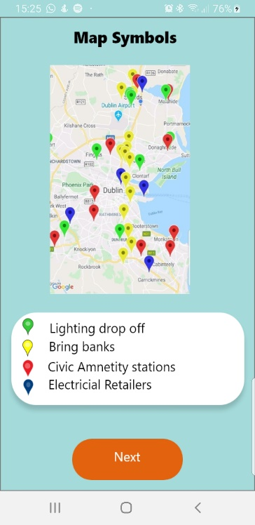

The user will then be presented with a filter screen, this filter screen allows the user to choose which county they would like to see results for, they can further filter it by choose which specific recycling source they would like to see although this is not required.

There are four scenarios with my map feature:

|  |
| --- |
| if (singlevalue.equals("specific location")) {  else if(singlevalue.equals("general locations")) {  else if(singlevalue.equals("specified outlet")){  else if(singlevalue.equals("classified item")) |

General locations are when the user chooses a county but no specified resource, e.g. if the user chose Cork and All. It will look like this:

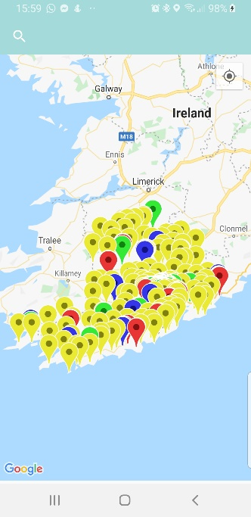

It is done by filtering the parsing to only get results with the chosen county, in this case, Cork:

intentcity = value.getStringExtra("city");

for (int i = 0; i < m_jArry.length(); i++) {  
  
 JSONObject jo_inside = m_jArry.getJSONObject(i);  
  
 if(jo_inside.getString("City").equals(intentcity)) {

The specified outlet scenario is very similar here, I parse through the list and look for Counties that equal the chosen county and recycling outlets that equal the chosen outlet.

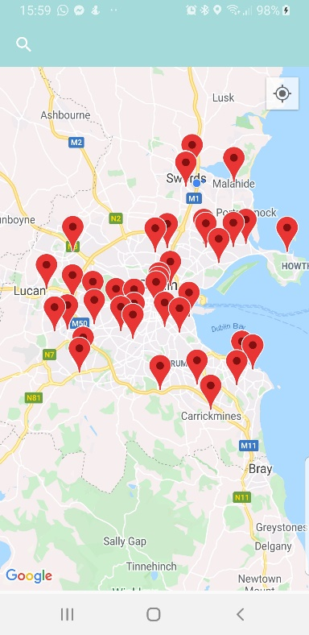

In this case, the user would have chosen Dublin and to see Civic Amenity sites.

intentcity = value.getStringExtra("city");  
  
for (int i = 0; i < m_jArry.length(); i++) {  
  
 JSONObject jo_inside = m_jArry.getJSONObject(i);  
 recycleoutlet = value.getStringExtra("recycleoutlet");  
  
 if(jo_inside.getString("City").equals(intentcity) & jo_inside.getString("Name").equals(recycleoutlet)) {

In some cases, smaller counties do not have the feature requested, e.g.: there may be no Civic Amenity sites in Galway. If a user chooses that combination, they will be given an error toast message, telling them the specified location does not have any of locations with that resource.

if(places.size() == 0)  
{  
 Toast.*makeText*(MapsActivity.this, "We are sorry it seems " + intentcity + " has no " + recycleoutlet + "'s", Toast.*LENGTH_LONG*).show();

The User can continually change and filter their map as much as they like through the side menu I created in the maps. A user can also search for a specific location in this sidebar; this will bring along the 3rd scenario “specific location”. In the example below, you can see the User searching for a specific location and it presenting resources in that location.

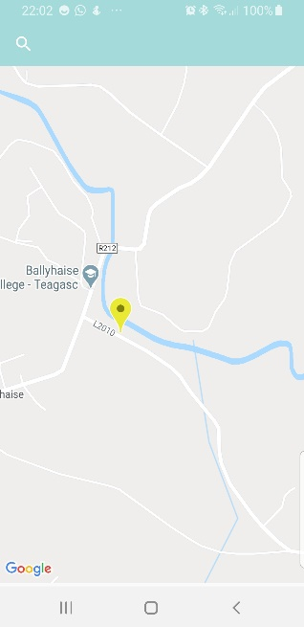 Once the location is clicked, the sidebar will close, and the user will be brought to that location as seen in the second picture. Although in this map it will display only resources within 10km from the location chosen helping to create an excellent user experience by not overpopulating the map and showing them what is needed.

It is done by getting the location of the users chosen marker and then only allow markers within a 10km radius of this to be added to the map.

lat = jo_inside.getDouble("lat");  
lng = jo_inside.getDouble("lng");  
  
Location target = new Location("target");  
target.setLatitude(lat);  
target.setLongitude(lng);  
if (marker.distanceTo(target) < 10000) {

The 4th scenario arises from the image classifier function if a user classifies a glass or metal item they will be allowed to find out where their nearest resource to recycle this is. For example, the user classifies an item that is glass they will be shown the nearest bottle banks.

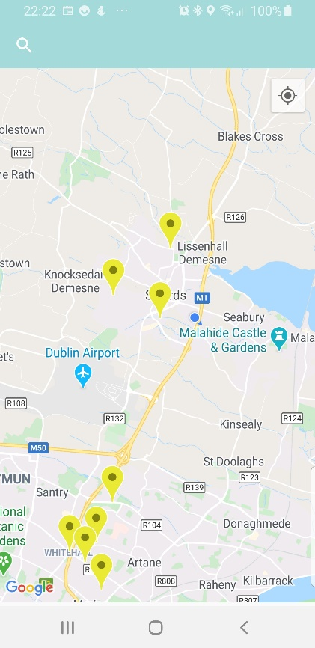

I first had to get the users location:

try {  
 Task locationResult = mFusedLocationProviderClient.getLastLocation();  
 locationResult.addOnCompleteListener(this, new OnCompleteListener() {  
 @Override  
 public void onComplete(@NonNull Task task) {  
 if (task.isSuccessful()) {  
 // Set the map's camera position to the current location of the device.  
 currentlocation = (Location) task.getResult();

for (int i = 0; i < m_jArry.length(); i++) {  
  
 JSONObject jo_inside = m_jArry.getJSONObject(i);  
 if (jo_inside.getString("Name").equals(recycleoutlet))

I then had to ensure that only the required outlets would be placed on the map.

I further then filtered these results to within 10km of their current location to show only locations in their close to them.

lat = jo_inside.getDouble("lat");  
lng = jo_inside.getDouble("lng");  
  
Location target = new Location("target");  
target.setLatitude(lat);  
target.setLongitude(lng);  
if (currentlocation.distanceTo(target) < 10000) {  
  
 places.add(new place(name, address, city, state, coordinantes, lat, lng));

Regardless of which map scenario you are in when a user clicks on a marker, they are presented with a popup screen telling them the recycle station it is. They are provided with the address the information on that station type further educating them and allowing them to understand what they can bring there. I then allowed them to get directions to that station; this was followed by directions to that station with the time and distance. I had to code algorithms to optimise the directions by coding algorithms, it allowed me to strategically work out the quickest and shortest route to take but still offering alternatives to them.

Each user can also add this location to their favourties. This will give the user a list of their favourite recycling stations sllowing them to see a clear map of their preffered locations. I used a regex statement to set the name and address when adding these to favourites.

place newplace = new place();  
LatLng posistion = marker.getPosition();  
lng = posistion.longitude;  
lat = posistion.latitude;

if(marker.getTitle().contains("Electrical Retailers")){

name = "Electrical Retailers";  
address = marker.getTitle().replace("Electrical Retailers " , "");

com.google.maps.model.LatLng destination = new com.google.maps.model.LatLng(  
 marker.getPosition().latitude,  
 marker.getPosition().longitude  
);  
DirectionsApiRequest directions = new DirectionsApiRequest(mCGeoApiContext);  
  
directions.alternatives(true);  
  
directions.origin(  
 new com.google.maps.model.LatLng(  
 currentlocation.getLatitude(),  
 currentlocation.getLongitude()  
 )  
);

directions.destination(destination).setCallback(new PendingResult.Callback<DirectionsResult>() {  
 @Override  
 public void onResult(DirectionsResult result) {  
 Log.*d*(TAG, "calculateDirections: duration: " + result.routes[0].legs[0].duration);  
 Log.*d*(TAG, "calculateDirections: distance: " + result.routes[0].legs[0].distance);  
 Log.*d*(TAG, "calculateDirections: geocodedWayPoints: " + result.geocodedWaypoints[0].toString());  
 addPolylinesToMap(result);

## Machine Learning Image Classifier

I used Tensor flow to build an image classifier, the classifier will distinguish what your item is, it gives users to understand what their item is and should they or should they not recycle it. I felt this brought a fun and interactive side to recycling, allowing the users to learn as they have fun. Each time a user classifies their image, they are brought to a screen in which tells them what their material is and tells them about their material.

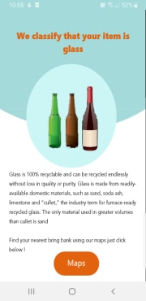

Here is an example when the user has a glass item, the app will classify it is glass, inform the user about glass, its recyclability and further with the click of a button the user will be shown all bring banks within 10km of their location.

You can use a technique known as transfer learning to re-train a model to recognize classes not in the original set. Transfer learning helped me make use of a sophisticated deep learning model with millions of parameters, ensuring my model would be accurate.

I used a technique known as transfer learning to re-train a TensorFlow model to recongise recycleable materials such as glass, plastic , paper etc. I first retrained the Tensorflow model using a code lab from google; I did this using python as it was the recommended language to use, and I had some experience coding in python from 3rd year. I used a dataset of 6024 images; these images were split between 5 classes

* Paper
* Plastic
* Glass
* Metal
* Trash

When training a model you have to choose how to split the images. This is the process of splitting the images from your data set, images to train the model and then images used to test the model. I split mine as follows: training data (80%), validation data (10%, optional) and testing data (10%).

train_data, rest_data = data.split(0.8)

validation_data, test_data = rest_data.split(0.5)

During the training process it I always good to plot the predicted result, I did this from 100 test images, showing predicted lables in red if they are wrong and green if they are correct. This helps to create an understanding to whether the model needs to be trained further or not.

**def** get_label_color(val1, val2):

**if** val1 == val2:

**return** 'black'

**else**:

**return** 'red'

plt.figure(figsize=(20, 20))

predicts = model.predict_top_k(test_data)

**for** i, (image, label) **in** enumerate(test_data.dataset.take(100)):

ax = plt.subplot(10, 10, i+1)

plt.xticks([])

plt.yticks([])

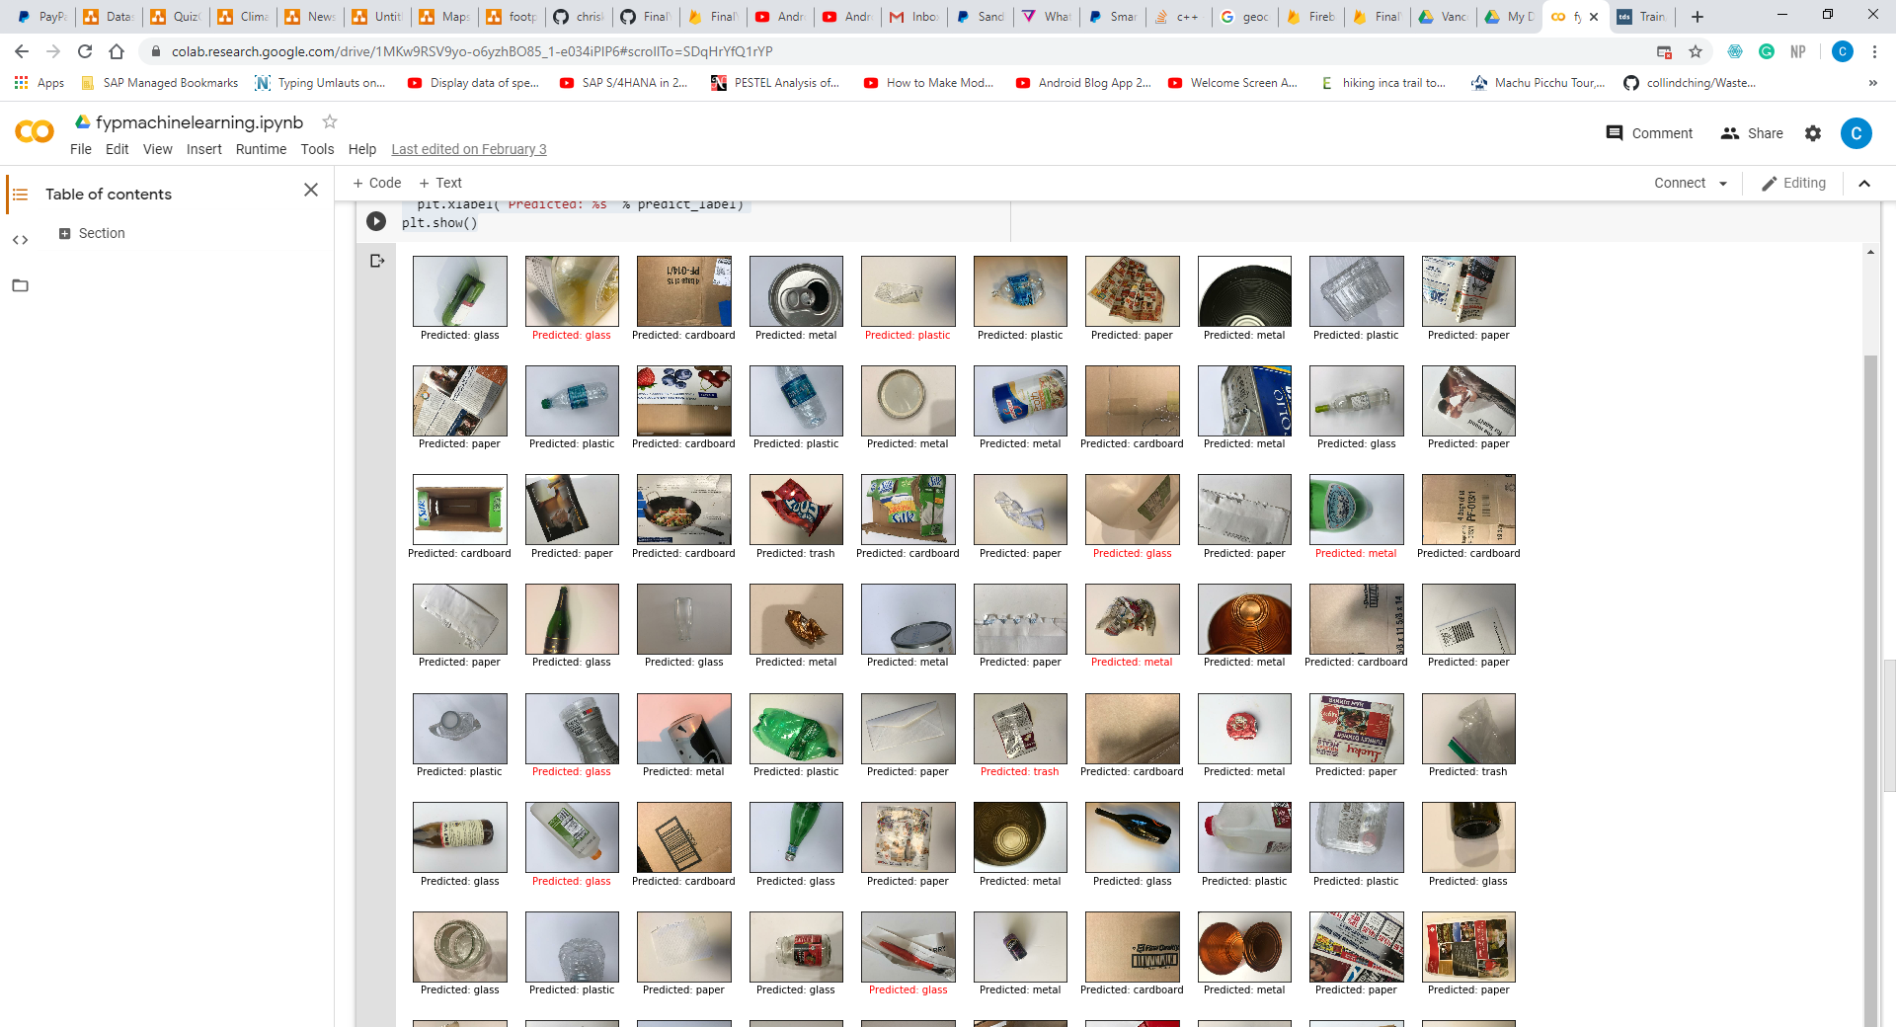 plt.grid(**False**)

plt.imshow(image.numpy(), cmap=plt.cm.gray)

predict_label = predicts[i][0][0]

color = get_label_color(predict_label,

test_data.index_to_label[label.numpy()])

ax.xaxis.label.set_color(color)

plt.xlabel('Predicted: **%s**' % predict_label)

plt.show()

The java and android studio side of it was facilitation of this model and integrating tensor flow to work in my application.

The classifier class contains most of the complex logic for processing the camera input and running inference, the two subclasses of this contain settings rather than additional processing logic. We perform inference by loading the model file and instantiating an interpreter.

In the Classifier constructor, we take the input camera bitmap image, convert it to a TensorImage format for efficient processing and pre-process it.

private TensorImage loadImage(final Bitmap bitmap, int sensorOrientation) {  
 // Loads bitmap into a TensorImage.  
 inputImageBuffer.load(bitmap);  
  
 // Creates processor for the TensorImage.  
 int cropSize = Math.*min*(bitmap.getWidth(), bitmap.getHeight());  
 int numRoration = sensorOrientation / 90;  
  
 ImageProcessor imageProcessor =  
 new ImageProcessor.Builder()  
 .add(new ResizeWithCropOrPadOp(cropSize, cropSize))  
 .add(new ResizeOp(imageSizeX, imageSizeY, ResizeMethod.*NEAREST_NEIGHBOR*))  
 .add(new Rot90Op(numRoration))  
 .add(getPreprocessNormalizeOp())  
 .build();  
 return imageProcessor.process(inputImageBuffer);  
}

The method recogniseImage accepts a bitmap and sensor orientation, runs inference, and returns a sorted List of Recognition instances, each corresponding to a label. The method will return the results bounded by MAX_RESULTS, which is 3 by default.

A priority Que is used to sort the images into a list of which item is the most probable.

private static List<Recognition> getTopKProbability(Map<String, Float> labelProb) {  
 // Find the best classifications.  
 PriorityQueue<Recognition> pq =  
 new PriorityQueue<>(  
 *MAX_RESULTS*,  
 new Comparator<Recognition>() {  
 @Override  
 public int compare(Recognition lhs, Recognition rhs) {  
 // Intentionally reversed to put high confidence at the head of the queue.  
 return Float.*compare*(rhs.getConfidence(), lhs.getConfidence());  
 }  
 });

ClassifierActivity is a subclass of CameraActivity that contains method implementations that render the camera image, run classification, and displayed the results.

Overall the use of Tensor flow was a learning process, the end function is very useful in my app and provides a very good functionality.

## Climate Change

The climate can be described as the average weather over a period of time. Climate change means a significant change in the measures of climate, such as temperature, rainfall, or wind, lasting for an extended period – decades or longer. Our climate is changing for the worse due to human activities, resulting in our planet becoming unhabitable. I wanted to use climate change to highlight to the user the results of what irresponsible recycling and misuse of the resources of our planet can lead to.

In the last year alone, ocean temperatures broke records, Antarctic melting reached unprecedented rates, and extreme weather swept through the US, Europe, and the Arctic.

Accelerated planet-wide warming has been linked to more species extinctions, an increased number of annual heat-waves, and more frequent natural disasters like wildfires and hurricanes.*(Business Insider)*

In the Climate change section of my app there are two main features animal extinction and the earth’s trimline.

### A screenshot of a cell phone Description automatically generatedAnimal Extinction

I also included an animal extinction section in this as I wanted to highlight to people that our actions do not affect just the human race but further affect all animals living in the wild.

I further wanted to include animals as I did much research on how humans sympathize with the death and harm of animals a lot more than that of humans. Hal Herzog, a professor of psychology, says that humans sympathize with animals as they are innocent. A study by Arnold Arluke, a professor of sociology, in the study humans were fed false articles covering the beating of a human baby, an adult, a puppy and an adult dog. Humans were equally most distraught by the beatings of the human baby and the puppy, followed not far behind was the adult dog. The adult was far behind all three; the common denominator for this was the innocence of the animal. (attn.com). This all is quite evident when we watch movies, including myself, show much more empathy when a dog or animal in the move dies over the death of a human.

I wanted to use this research and knowledge to my advantage; I want humans to see their actions are massively affecting these innocent and vulnerable animals. I feel like it not only educate the users, but it will have a more impacting and lasting effect.

The User will first be brought to A screen informing them of the mass extinction of animals and how climate change is contributing to this. It will allow the User to be educated immediately and push them to understand that their actions up until now are not good enough driving them on to change for the better.

The initial screen is followed by the user being presented a recycler view of 14 animals; the user can click into any animal to find out more information. Naturally, some humans might take the stance and wonder how this affects us if the animal goes extinct. I wanted to display not only is climate change contributing to the mass extinction of animals, but these animals’ matter to us and their extinction can result in drastic effects on human life. I then present the exact reason for their extinction; these reasons vary depending on the animal. Some are because of global warming; other reasons include loss of habitat. Overall the aim here is to leave the user with a sense of responsibility and to use this to make them become more environmentally friendly.

Each animal will have an adopt button on their screen. This will give the user to adopt an animal to help fight against the extinction of that animal. WWF work to protect wildlife that are endangered of going extinct. . They focus their efforts on those species on animals whose protection influences and supports the survival of other species or offers the opportunity to protect whole landscapes or marine areas. This adoption would be completed through my app to adopt an animal from WWF.

I chose to use PayPal for this adoption payment. The user is giving three options when they choose to adopt. A gold package, silver package and a bronze package. Each package varies in prize and what you receive from each package naturally also varies.

After the user chooses which package, they want to purchase they will be brought to a screen in which they choose if they would like to pay by card or PayPal.

I pass over the chosen value this will represent the price of the donation, in the examples case the user has chosen the gold package worth €100

if(packageoption.equals("Gold"))  
{  
 amount = 100;

I then check if the request code matches and ensure the payment has been confirmed before bringing the user to the confirmation page.

if (requestCode == *Paypal_requestCode*) {  
 if (requestCode == *RESULT_OK*) {  
 PaymentConfirmation confirmation = data.getParcelableExtra(PaymentActivity.*EXTRA_RESULT_CONFIRMATION*);  
 if (confirmation != null) {  
 try {  
 String paymentDetails = confirmation.toJSONObject().toString(4);  
  
 startActivity(new Intent(this, paymentconfim.class)  
 .putExtra("paymentDetails", paymentDetails)  
 .putExtra("PaymentAmount", amount));

### Earth’s Timeline

If we take the current climate growth, from 2001 to 2019 we have seen 18 of the 19 warmest years ever. It highlights our planet is continually rising in temperatures. These tempertures are absolutely destroying our planet, it easy to ignore these changes in our daily lives, but soon our daily lives will be be completely changed due to global warming and climate change.

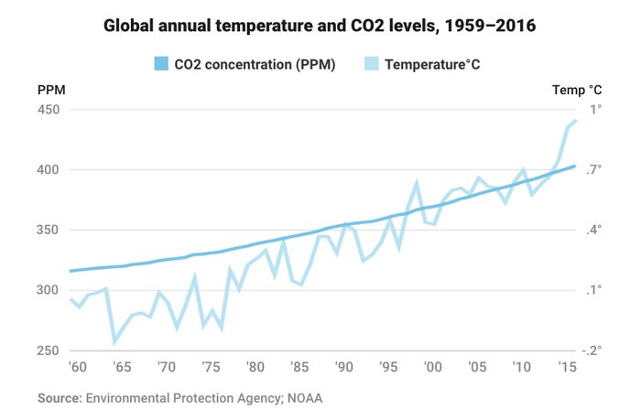

Climate change is linked to more warm, dry days in regions with a risk of wildfires, like California. In November 2018, the most deadly and destructive wildfire in the state's history — the Camp Fire — started during what is typically the rainy season*. (Business Insider)*

Over the last year alone we have seen some of the most destructive fires to the planet. In 2019 we saw the Amazon have its largest forest fire ever. When the burning of the Amazon was at its peak in August, there were thousands of individual fires, almost three times as many that month - 30,901 - compared with the same period last year. (bbc).

Just this year we saw the Austrailian bush fires, these fires shocked the globe as they massively impacted the whole continent. Bush and grass fires scorched 5.5 million hectares of land in New South Wales (NSW) alone, blackening an area that accounts for more than six percent of the state. Within the southeastern state, fire destroyed a total of 2,448 homes and claimed 25 lives*. (The verge).*

It is quite evident that our planet is changing and of the worse. I wanted to highlight this in my earth’s timeline feature. I do this my presenting 3 globes, past, present and future. The past globe highlights the globe during the ice age 2 million years ago, I tell the user how it almost took one million years for earth to become habitable after the ice age. I wanted to educate the user and show them that our planet has took a very long time to reach these liveable conditions.

The present globe highlights the planet at it’s current state, habitable, and perfect conditions with the correct temperatures. This is then followed by what the planet will look like in 100 years if we continue with our destructive habits. I want to show the user what the planet will look like, and how this affects us. Highlighting that it will be unhabitable.

To get my message across I wanted to make the globes as realistic as possible, so I combined graphics I made on Illustrator and Video editing from After effects to develop spinning globes. The user can then select which globe they would like to see from the timeline.

future.setOnClickListener(new View.OnClickListener() {  
 @Override  
 public void onClick(View view) {  
 bg.setBackgroundResource(R.drawable.*futuretimeline*);  
 earthgif.setImageResource(R.drawable.*earthburn*);

# Test Plan

|  |  |  |  |  |
| --- | --- | --- | --- | --- |
| Test Case | Test Scenario | Expected Result | As expected | Pass |
| Register | Ability of a user to register | User registered and added to the database | As expected | Pass |
| Login/ Log out | Ability of a user to login and logout | The user can log in and log out of their profile | As expected | Pass |
| Choose the latest News | The user should have the ability to see the latest news | The latest news will appear on a new screen | As expected | Pass |
| Customise the news | The user must be able to choose which news outlet they want to see from the list of available outlets | The User should see only news from their selected domain | As expected | Pass |
| See their favourite articles | The user should be able to see their favourite articles | The articles that have been favorited by the user should only appear | As expected | Pass |
| Read any article they want to | The user must be able to view the article in full if they choose to . | The user must be able to choose the article and read it in full. | As expected | Pass |
| Add article to favourites | The user must be able to add an article to favourites | The article is added to the database to the user’s favourite articles | As expected | Pass |
| Answer all footprint questions footprint function | The user must be able to answer all questions | Continuation on to the next question until finished | As expected | Pass |
| Test Case | Test Scenario | Expected Result | Actual Result | Pass/Fail |
| Throw error message for incorrect messages | The user will receive an error message | If the user answers a number question with a letter or blank space they will get an error | As expected | Pass |
| Receive a carbon footprint total | When finished the user will receive a footprint total | The user will receive a result and it will be pushed to the db | As expected | Pass |
| View the results sheet from their footprint | The user must be able to view the results sheet showing a pie chart of their results | A pie chart appears with each section included | As expected | Pass |
| Choose a specific category for advice | The user must have the capabilities to choose the category for advice | The user will be brought to an advice screen for that specific category | As expected | Pass |
| See all three tips in the food section | The user must be able to see all three tips in their food section | The user can switch between three tips | As expected | Pass |
| See all three tips in the travel section | The user must be able to see all three tips in their travel section | The user can switch between three tips | As expected | Pass |
| See all three tips in the home section | The user must be able to see all three tips in their | The user can switch between three tips | As expected | Pass |
| See all three tips in the purchasing section | The user must be able to see all three tips in their purchasing section | The user can switch between three tips | As expected | Pass |
| Test Case | Test Scenario | Expected Result | Actual Result | Pass/Fail |
| See their history for footprint calculations | The user must be able to view their previous footprints | The user can see their previous footprint attempts | As expected | Pass |
| See their history for travel footprint | The user can see the footprint for solely travel | Presented with a link chart of their previous footprints | As expected | Pass |
| See their history for food footprint | The user can see the footprint for solely food | Presented with a link chart of their previous footprints | As expected | Pass |
| See their history for purchasing footprint | The user can see the footprint for solely purchasing | Presented with a link chart of their previous footprints | As expected | Pass |
| See their history for home footprint | The user can see the footprint for solely home | Presented with a link chart of their previous footprints | As expected | Pass |
| Follow map instruction | The user must be able to pass through the map instructions | The user can continue through the map to the filter screen | As expected | Pass |
| Filter the map at the introduction stage | He user can select any county and station they like | The ma opens only with the chosen results | As expected | Pass |
| The user can select their favourite locations | The user can select their favourite locations as an alternative to filters | The map opens with the users favourite results | As expected | Pass |
| Zoom in and out, scroll through the map | The user can use regular maps functions | Zoom in/out, scroll all works with out error | As expected | Pass |
| Test Case | Test Scenario | Expected Result | Actual Result | Pass/Fail |
| View the side bar | The user can open the side bar of the menu | The side bar opens when the user clicks on it | As expected | Pass |
| Filter the map | The user must be able to filter the map while in google maps | Locations on the map are changed based on new filter | As expected | Pass |
| Search the recycler view | The user must be able to search the recyclerview for a specific location | Locations appear in the list based on the users search | As expected | Pass |
| Click on a specific location | The user must be able to click on a specific location and be brought to this location | The user can click on a marker | As expected | Pass |
| The user can get directions | The user must be able to click on the directions tab and get directions | Directions appear on the map | As expected | Pass |
| The user can add a location to their favouite | The must have the capabilities to add a location to favourites | The location is added to the db to the users favourtie locations | As expected | Pass |
| Must be able to return to the map screen | The user can return to the map through the side bar | The map is returned full screen | As expected | Pass |
| Return to the main menu from maps | The user must be able to return to the home screen from the maps function | The user is returned to the app main menu | As expected | Pass |
| Test Case | Test Scenario | Expected Result | Actual Result | Pass/Fail |
| Choose which quiz they would like to do | The User can choose whichever quiz they like | The Quiz menu opens when chosen | As expected | Pass |
| Choose which level they would like to take part in | The user can choose what level they do in the quiz | After selecting the level the quiz opens | As expected | Pass |
| Answer each question in the quiz | The user must be able to answer all the questions in the quiz. | After answering a question the answer is presented | As expected | Pass |
| Be provided with results from the quiz | The user must be provided with the results from their quiz | It allows them to see their results they will be told how many questions have been added to their review questions | As expected | Pass |
| Choose one of the three options on the recycle menu | The user must be able to choose between the menu items in the recycle menu | The function menu opens for the selected function | As expected | Pass |
| Scroll through materials list | The user must be able to scroll through the list of materials | The list is scrolls without error | As expected | Pass |
| Search for materials | The user can search for materials in the search bar | Materials appear in the list based on the search preference | As expected | Pass |
| Select one of the four items at the top | The user must be able to select one of the four items at the top of the screen | The details of the selected item opens | As expected | Pass |
| Choose any item from the list | The user must be able to choose any item from the list | The details of the selected items opens | As expected | Pass |
| Add an item to favourites | The user should be able to add a material to favourites | The material is added to the database for the users favourite material | As expected | Pass |
| Change the list of materials to favourites | The user can choose to see only their favourite materials | A list of the users favourite items come up only | As expected | Pass |
| Follow the instructions on the classifier | The user must be able to follow the instructions on the classifier | The User continues through the instructions to the classifier | As expected | Pass |
| Open their camera in the classification section | The user must be able to open their camera in the classification section | The user can open their camera without error | As expected | Pass |
| Classify an item | The user must be able to classify which item is in their camera | The user can see the result of the item | As expected | Pass |
| Results screen appears | The user must be able to see the results of their classification | A screen with the results of what material appears | As expected | Pass |
| Open maps function based on what materials appear | The user can open the maps function based on the classification results | The maps function opens with customized results | As expected | Pass |
| Choose a menu item from the climate change menu | The user must be able to choose between the two menu options | The functionality opens | As expected | Pass |
| Read and proceed from the initial animal introduction screen | The user can continue from the introduction screen | List of animals open on a new screen | As expected | Pass |
| Select a specific animal from the recycler view list | The user must be able to choose which animal they would like to see | The details of the animals open | As expected | Pass |
| Adopt an animal | The user can adopt an animal be click the adopt button | The Package screen opens | As expected | Pass |
| Read and proceed from the initial planet introduction screen | The user can continue from the introduction screen | The Timline page opens up | As expected | Pass |
| Change between planets | The user can change between planets | When a new time is selected the earth changes | As expected | Pass |
| View their own profile | The user must be able to view their profile | The user must be able to view their profile for them to edit details | As expected | Pass |
| Edit personal details | The user must be able to edit their personal details | Personal Details are changed | As expected | Pass |
| Change their profile photo | The user should be able to change their profile photo | Photo changes | As expected | Pass |

# My Difficulties and what I have learned overall

Overall building my very own app was a rewarding experience, it is exciting to see something you have spent so long on come to fruition.

Throughout the process I faced many difficult challenges. I have never taught of myself as the most technically gifted developer so developing a full stack application really posed some coding challenges from very to very large. One of my main issues was the footprint calculator. I originally wanted a more simplified API, I went about this by contacting every website and person I could find who used a footprint calculator. Unfortunately, all these requests to use their calculator as an API were followed by legal issues and standpoints that made it not possible. Using the Cool Climate API proved more complicated than I had originally anticipated as I had to put in a lot of research on each topic it wasn’t as simple as having the user answer questions. Parsing the results to the online API was the biggest difficulty it seemed that it was slightly different as I was doing it on android, and it resulted in a very frustrating process.

Although small bug fixing was another issue, there were several times my code wouldn’t work like I wanted, due to very small errors I overlooked. There were many times I went through my code 5 or 6 times before realizing I haven’t done some very simple like initialize a variable. It taught me to follow a process when coding and enhanced my skills with finding errors and fixing code.

Tensor Flow with machine learning caused many complications, the model was not the most difficult to build but using this model to suit android really was a tiring and frustrating process. Although Tensor flow had a lot of documentation it felt like I was running into endless amounts of problems before finally completing it.

I felt like I was really organized throughout the process, I had weekly meetings with paddy from the very start this really helped me keep on track. Although I believe I could have used additional support on this such as a project management tool. There were many times I can easily get distracted from what I am currently working on and try to start a new function without fully finishing the last one. I believe a project management tool might have combatted this.

Overall, I learnt a lot, I believe my coding ability and skills have progressed leaps and bounds, I have gone from being very hesitant ad having a negative attitude towards coding to really enjoying it and taking a development consultancy role in SAP. I further have enhanced my problem-solving skills and business analytical skills. While developing the app and doing research I reached out to many business leaders in the same market as my app, I learnt a lot from this many gave me advice on why some business functions weren’t working and how they could be enhanced. It additionally helped me network and build connections with some very good business leaders.

# References:

<https://www.nationalgeographic.com/>

<https://www.mywaste.ie/>

<https://climate.nasa.gov/effects/>

<https://blogs.psychcentral.com/mindfulness/2016/09/relax-your-brain-youll-learn-more-and-be-happier/>

<https://www.unicaf.org/balancing-your-studies-with-relaxation/>

<https://wwf.panda.org/knowledge_hub/teacher_resources/webfieldtrips/climate_change/>

<https://wwf.panda.org/>

<https://www.unicef.ie/>

<https://archive.attn.com/stories/8934/why-humans-tend-to-sympathize-more-with-animals-than-other-humans>

<https://www.bbc.com/news/science-environment-46384067>

<http://www.recycling-guide.org.uk/>

<https://greenerideal.com/news/environment/0703-7-amazing-recycling-facts/>

<https://www.met.ie/recent-warm-weather-report-up-to-6th-july-2018>

<https://www.eea.europa.eu/airs/2018/resource-efficiency-and-low-carbon-economy/environmental-goods-and-services-sector>

<https://www.theguardian.com/environment/2019/jun/05/greta-thunberg-effect-public-concern-over-environment-reaches-record-high>

Effects | Facts – Climate Change: Vital Signs of the Planet. <https://climate.nasa.gov/effects/>

<https://gemreportunesco.wordpress.com/2015/12/08/education-increases-awareness-and-concern-for-the-environment/> world education blog

<https://www.theguardian.com/sustainable-business/blog/time-businesses-go-green-roi>

Guardian

<https://www.forbes.com/sites/natalieparletta/2019/05/14/going-green-whats-good-for-the-planet-is-good-for-business/#679f1f6f3201>

<https://www.businessinsider.com/paris-climate-change-limits-100-years-2017-6?r=US&IR=T#warming-waters-are-also-melting-arctic-and-antarctic-glaciers-from-underneath-in-2012-greenland-lost-more-than-400-billion-tons-of-ice-which-was-almost-quadruple-the-amount-of-loss-in-2003-5>

<https://www.theverge.com/2020/1/3/21048891/australia-wildfires-koalas-climate-change-bushfires-deaths-animals-damage>